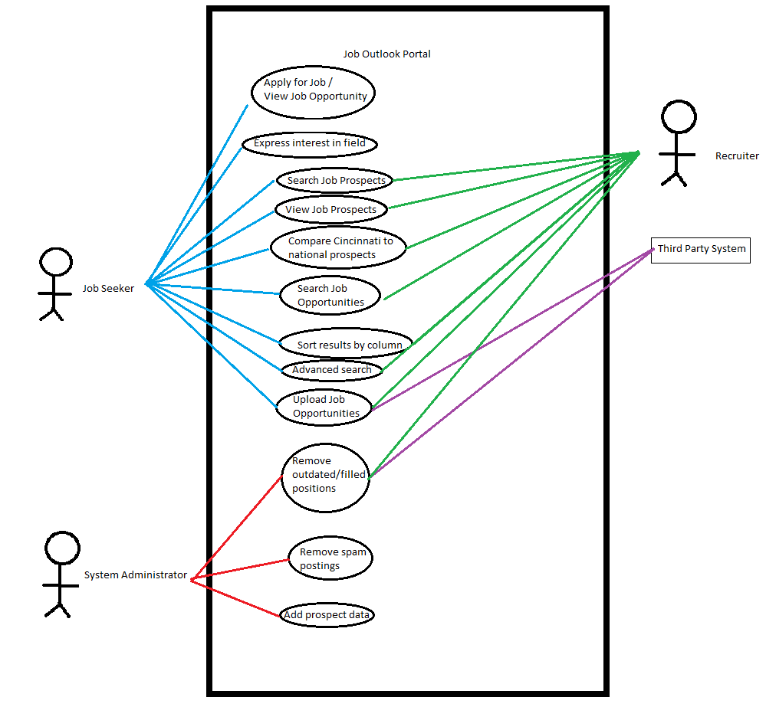

# Use cases

* Apply for job / View Job Opportunity
  + See below
* Express interest in field
  + See below
* Search Job Prospects
  + See below
* View Job Prospects
  + See below
* Compare Cincinnati to national prospects
  + Provides an overview of Cincinnati prospects against national equivalents. Shows best/worst jobs for this area by availability. Shows trends in growth over time.
* Search Job Opportunities
  + Allow Job Seeker / Recruiter to search available job opportunities for potential employment.
* Sort Results by column
  + Allow user to sort results of Job Opportunity and Job Prospect searches by column.
* Advanced search
  + Allow user to narrow search results for Job Opportunity and Job Prospect with multiple criteria.
* Upload Job Opportunities
  + Allow Recruiter/Third Party site to upload a Job Opportunity to system. User provides contact information for application notifications.
* Add prospect data
  + Allow System Administrator to upload prospect data for job fields.
* Remove outdated/filled positions
  + Allow Recruiter / System Administrator to remove outdated and/or filled positions
* Remove Spam Postings
  + Allow System Administrator to remove content that detracts from spirit of website.

| **Use Case Section** | **Comment** |
| --- | --- |
| **Use Case Name** | View Job Prospect |
| **Scope** | The system under design. |
| **Level** | User-Goal |
| **Primary Actor** | Job Seeker; Recruiter |
| **Stakeholders and Interests** | Job Seeker: Wants to view strength of job field in Cincinnati area. Looking for trends revealing thriving/failing markets to evaluate employment potential.  Recruiter: Wants to view strength of job field in Cincinnati area. Looking for trends revealing thriving/failing markets to adjust recruiting efforts. Wants Job Seekers to obtain attractive and accurate information.  Third Party Site: Wants Job Seekers to obtain attractive and accurate information. |
| **Preconditions** | User has identified a job field whose prospects they wish to investigate further. |
| **Success Guarantee** | User has obtained knowledge of job prospects in relevant field. User is provided link to a job search related to their selected field. |
| **Main Success Scenario** | 1. User enters home page for specified job field 2. User is presented options to view data in graphs, charts and/or maps 3. User selects an option 4. User peruses onscreen information. 5. Repeat steps 3-4 until satisfied. |
| **Extensions** | At any time user may leave this section   * no effects   At any time user may select link to related Job Opportunites   * System captures specifics of current job prospects and feeds it into a Job Opportunity search * Results are displayed to user * See Search Job Opportunities UC |
| **Special Requirements** | N/A |
| **Technology and Data Variations List** | These pages shall be read only. The only user interface will be selection of display medium. |
| **Frequency of Occurrence** | Most visitors may use this feature. |
| **Miscellaneous** | Such as open issues. |

| **Use Case Section** | **Comment** |
| --- | --- |
| **Use Case Name** | Express interest in field |
| **Scope** | The system under design. |
| **Level** | subfunction |
| **Primary Actor** | Job Seeker |
| **Stakeholders and Interests** | Job Seeker: Wants to share information with friends and other interested parties. Wants to engage socially with website.  Recruiter: Wants to view interest in field by user. May use this information for targeted recruitment focus. May influence frequency of job posts |
| **Preconditions** | User must have found job field of interest. |
| **Success Guarantee** | User has “liked” a job field. Accumulated total of likes for field displayed to all users. |
| **Main Success Scenario** | 1. User is investigating a job field for opportunities or prospects. 2. User broadcasts interest in field by clicking “like” or similar button 3. Accumulated total of likes for field displayed to all users. |
| **Extensions** | Alternate scenarios of success or failure. |
| **Special Requirements** | N/A |
| **Technology and Data Variations List** | N/A |
| **Frequency of Occurrence** | Proportional to number of millennials using system. |
| **Miscellaneous** | Possible social network integration |

| **Use Case Section** | **Comment** |
| --- | --- |
| **Use Case Name** | Apply for Job |
| **Scope** | The system under design. |
| **Level** | user-goal |
| **Primary Actor** | Job Seeker |
| **Stakeholders and Interests** | Job Seeker: Wants to quickly apply for employment opportunity. Wants to upload resume/cover letter with application. Wants to receive confirmation when application is received.  Recruiter: Wants accurate records and applicant information. Wants to be notified when application is received.  Third Party Site: Wants accurate records and applicant information. Wants to be notified when application is received. |
| **Preconditions** | Job opportunity has been posted by recruiter/third party site. Job opportunity found by interested applicant. |
| **Success Guarantee** | Job Seeker application sent to recruiter/third party. Recruiter/third party site notified of application. Job Seeker notified application under consideration. |
| **Main Success Scenario** | 1. Job Seeker selects Job Opportunity of interest. 2. System displays Job Opportunity details and qualification 3. Job Seeker reads details and qualifications. 4. Job Seeker indicates wish to apply for position 5. System displays application or provides link to application on third-party site. 6. Job Seeker enters information 7. Job Seeker submits information 8. System notifies Recruiter/Third Party 9. System notifies Job Seeker application is under consideration |
| **Extensions** | At any time, Job Seeker may return to search results and cancel submission   * System cancels all progress and returns to previous search results.   Recruiter/Third Party contact information may be outdated/wrong  * Notify user that submission could not be verified. Try another job. :( |
| **Special Requirements** | N/A |
| **Technology and Data Variations List** | N/A |
| **Frequency of Occurrence** | Could be nearly continuous |
| **Miscellaneous** | Should we allow user to save progress?  Should we allow user to bookmark Opportunities  Should |

| **Use Case Section** | **Comment** |
| --- | --- |
| **Use Case Name** | Search Job Prospects |
| **Scope** | The system under design. |
| **Level** | User-Goal |
| **Primary Actor** | Job Seeker; Recruiter |
| **Stakeholders and Interests** | Job Seeker: Wants to view strength of job prospects in Cincinnati area. May narrow to a specific job field. Looking for trends revealing thriving/failing markets to evaluate employment potential.  Recruiter: Wants to view strength of job prospects in Cincinnati area. May narrow to a specific job field. Looking for trends revealing thriving/failing markets to adjust recruiting efforts. |
| **Preconditions** | Prospects must be entered by System Administrator |
| **Success Guarantee** | User will have a list of Job Prospects matching specified search criteria |
| **Main Success Scenario** | 1. User visits Search For Job Prospects area of site 2. (optional) User enters search criteria to narrow results 3. Job Prospects matching user’s search criteria are displayed. If no criteria is entered, all results are displayed. 4. Repeat steps 2 & 3 until a satisfactory result is found 5. User selects Job Prospect of interest 6. Continue to View Prospects Use Case |
| **Extensions** | At any time user may stop searching  A search may not return any results if criteria are too specific. Notify user to alter criteria and before continuing to search. |
| **Special Requirements** | N/A |
| **Technology and Data Variations List** | * User may sort results by column |
| **Frequency of Occurrence** | Influences investigation, testing, and timing of implementation. |
| **Miscellaneous** | Such as open issues. |